Fluorescence Correlation Spectroscopy (FCS)
LAB

Day 1 :
1 / Microscope configuration & Alignment
- Design a scheme of the FCS microscope installation used for the experiments. Briefly describe what the specifics of this configuration are.
- Describe the protocol for aligning the excitation and emission paths. Do we need to align the pinhole?
2 / Excitation Volume Calibration. Use a solution of 60 nM Fluorescein in Tris pH 9. 780 nm and 10 mWatt. Assume a diffusion constant of 425 μm²/s to fit the autocorrelation function. What is the value of W₀ and Z₀? Calculate the excitation volume.
3/ Acquire FCS data for mysterious solutions. Fix the values ​​characterizing the size of the beam obtained previously to calculate the apparent concentration and diffusion coefficient of each solution.
What are the observations made during these experiments? Explain and Discuss the results obtained.
Day 2 :
N&B Experiment on living Cell:
- Write down the materials and methods for the live cell imaging microscopy practical workshop. Read M&M of Guiziou S. et al. Nucl. Acids Res.(2016) doi: 10.1093/nar/gkw624. Read the entire paper Zuniga A. et al. ACS Synth. Biol. 2021, 10, 3527−3536.
- What should be the residence time, the number of images and the size of the pixels for these experiments? Explain your choices.
- Do the mEGFP number and brightness vary from one strain to another? Explain and discuss the result.
Fluorescence Correlation Spectroscopy (FCS)
NOTES

1. AUTOCORRELATION FCS (Elson & Magde, 1974; Schwille & Haustein, 2009)
In FCS, the fluctuations of fluorescence intensity F(t), emanating from a very small volume (confocal or two-photon) correspond to the difference between the intensity at time, t, and the average fluorescence intensity, <F(t)>. These fluctuations are time-correlated to generate an autocorrelation function G(), defined as The autocorrelation can be calculated from data collected on 2 photon FCS microscope, as :
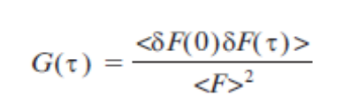
where
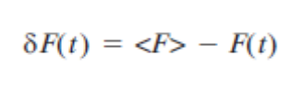
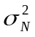The fluctuations of the number of molecules present in the observation volume due to diffusion follows a Poisson distribution, characterized by an average number <N>. For a Poisson distribution, the variance of this fluctuation is equal to its mean, ie <N>.
As a consequence, for simple systems in which the particles have all the same brightness at =0,
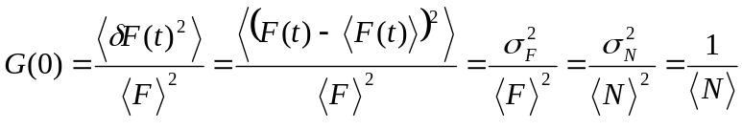

Thus, the amplitude of the fluorescence signal at =0 is inversely proportional to the concentration of molecules (see Figure below)
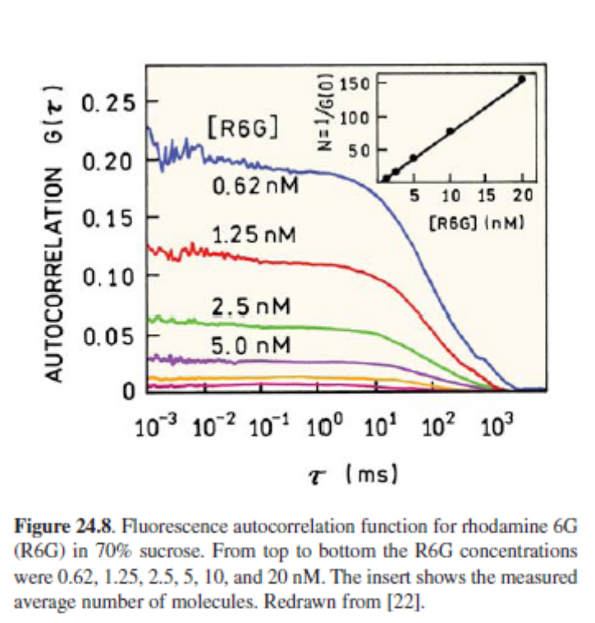

The shape of the observation volume in a confocal or 2-photon instrument is the point spread function (PSF). The 3D Gaussian and Gaussian–Lorentzian shapes have been commonly used to described the PSF. The volume for a 3D Gaussian shape is:
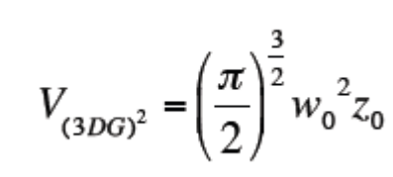
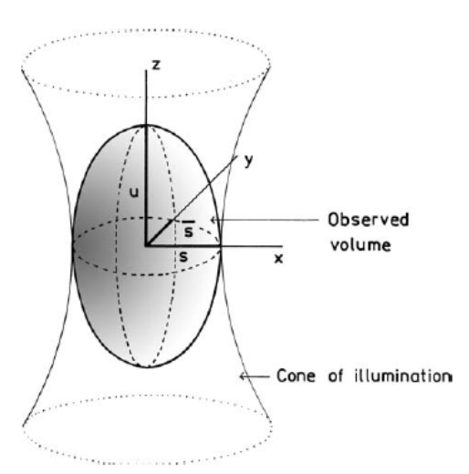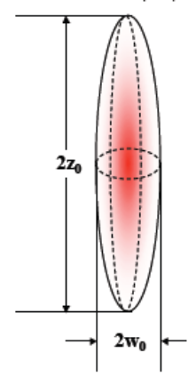

Where w₀ and z₀ are the radial and axial radius, respectively. The equation for 2 photon case related the autocorrelation G() to the particle diffusion is given as:
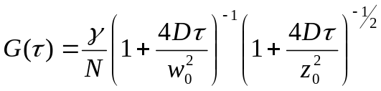

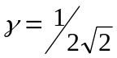
Where  is the shape factor ( for 3D Gaussian PSF), and D is the diffusion coefficient of the molecule. Note that for 2-photon excitation the factors 4 become 8, due to the quadratic dependence of fluorescence intensity on excitation intensity in two-photon excitation.
The diffusion constant shifts the decay of the autocorrelation function in time (see below, right), while the number of particles influences the amplitude at time zero G(0) (see below, left)

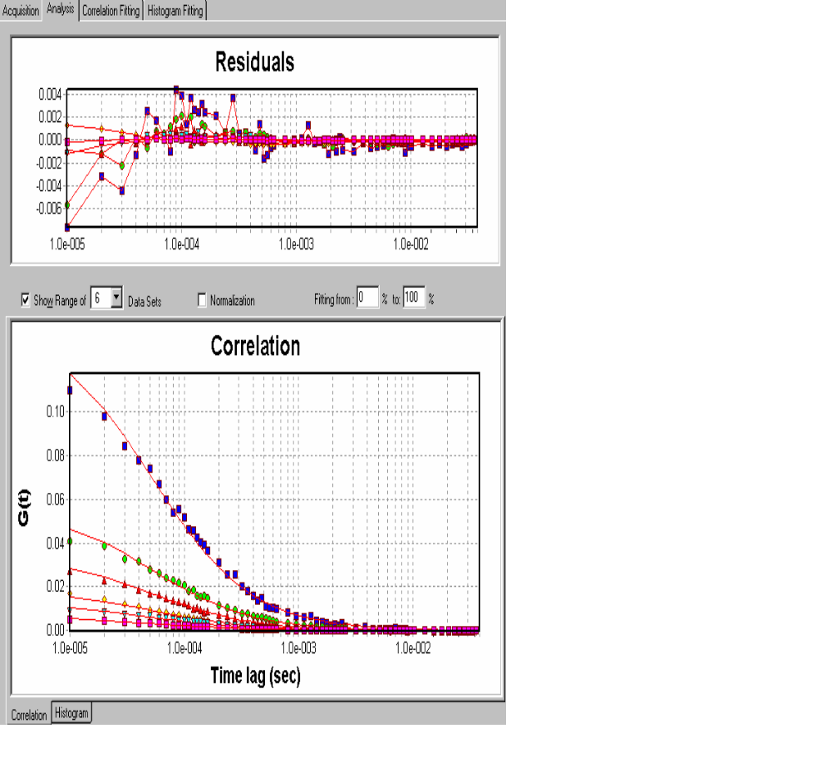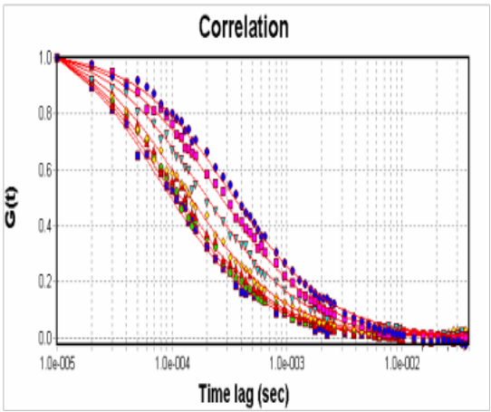

3. NUMBER & BRIGHTNESS (N&B) (M. a Digman, Stakic, & Gratton, 2013; M. A. Digman, Dalal, Horwitz, & Gratton, 2008; Qian & Elson, 1990)
N&B is a moment analysis method based on the determination of the first (average intensity) and second (variance) moments of the intensity distribution. For the sum of counts k_{i} obtained during the integration time t, the average and variance are given by:
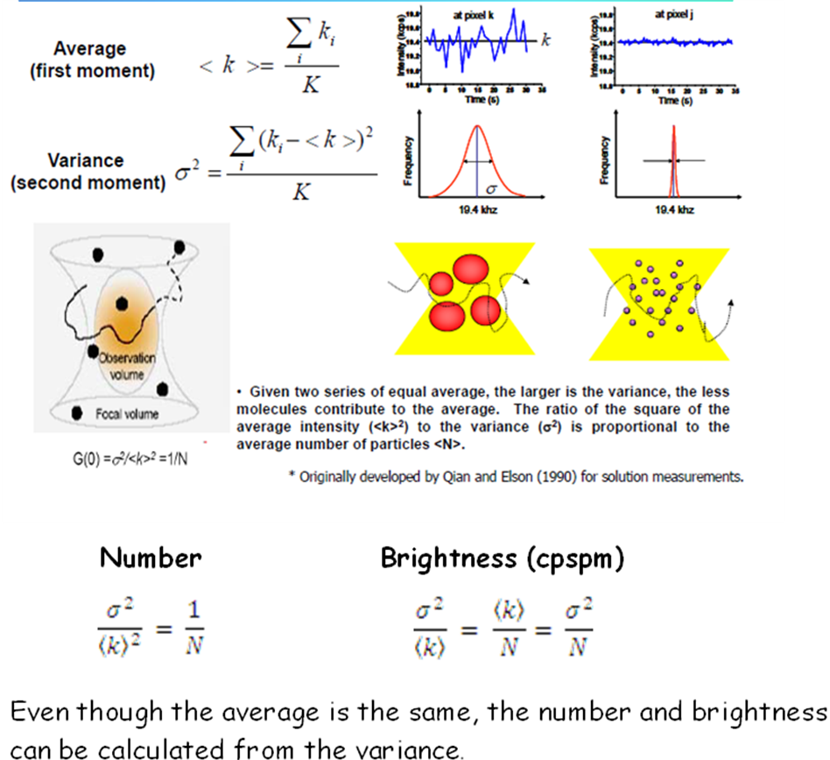
If the particle is very bright and there are a few particles in the observation volume, the fluctuations due to the occupation number prevail. The average number of particle in the volume of excitation <N> and the apparent Brightness B are defined as:

Some Key references:
Bacia, K., Kim, S., & Schwille, P. (2006). Fluorescence cross-correlation spectroscopy in living cells. Nature methods, 3(2), 83–89. doi:10.1038/NMETH822
Digman, M. a, Stakic, M., & Gratton, E. (2013). Raster image correlation spectroscopy and number and brightness analysis. Methods in enzymology (1st ed., Vol. 518, pp. 121–44). Elsevier Inc. doi:10.1016/B978-0-12-388422-0.00006-6
Digman, M. A., Dalal, R., Horwitz, A. F., & Gratton, E. (2008). Mapping the number of molecules and brightness in the laser scanning microscope. Biophys J, 94(6), 2320–2332.
Elson, E. L., & Magde, D. (1974). Fluorescence correlation spectroscopy. I. Conceptual basis and theory. Biopolymers, 13, 1–27.
Qian, H., & Elson, E. L. (1990). On the analysis of high order moments of fluorescence fluctuations. Biophysical journal, 57(2), 375–80. doi:10.1016/S0006-3495(90)82539-X
Schwille, P., & Haustein, E. (2009). Fluorescence correlation spectroscopy An introduction to its concepts and applications. Spectroscopy, 1–33.

